Money
# Source: AI Source: Provided by: [Data Path: Persons Table -> ID Column: 1, Name_En Column: Motasem Essam] -> From: [ChatGPT] on [7/17/2026]
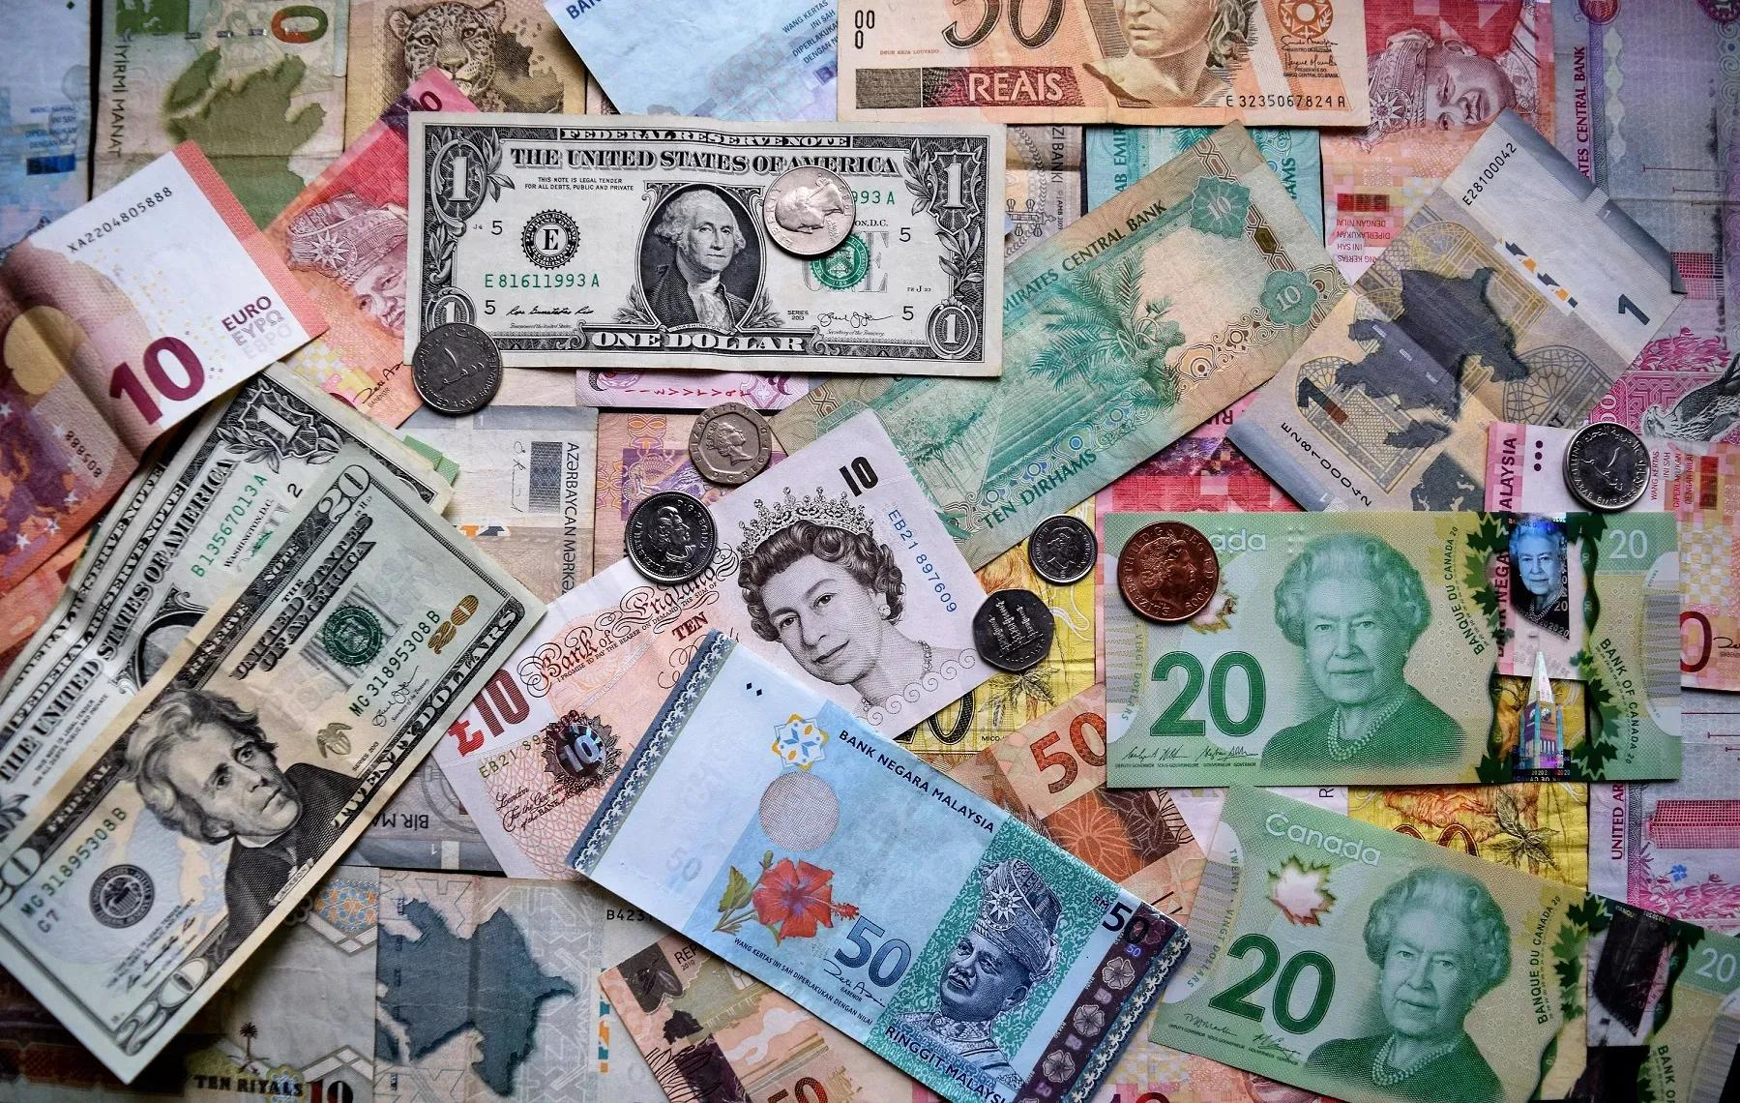
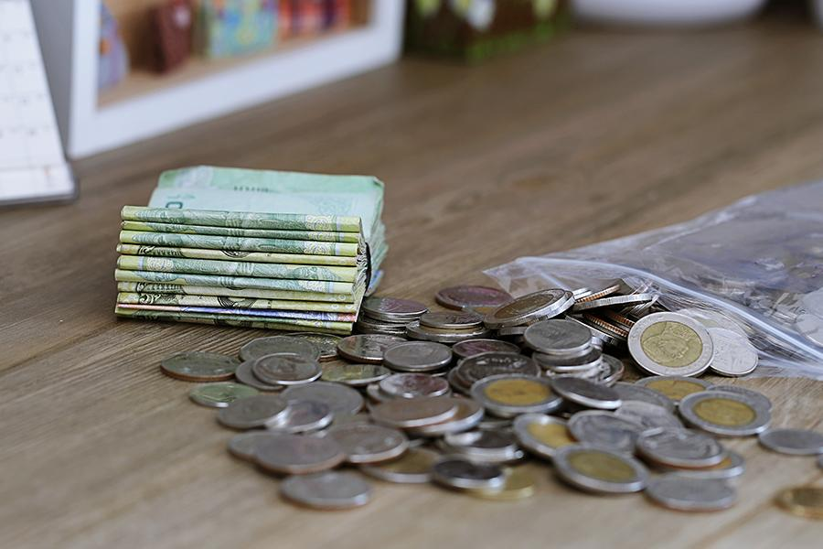

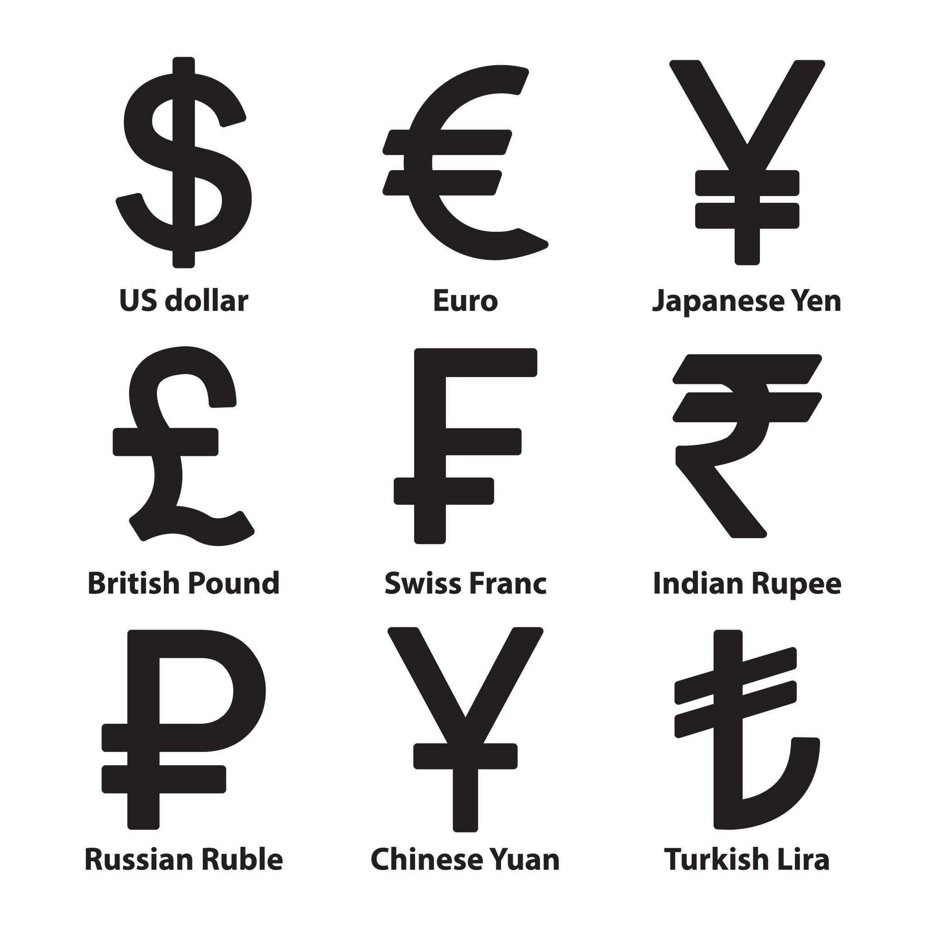
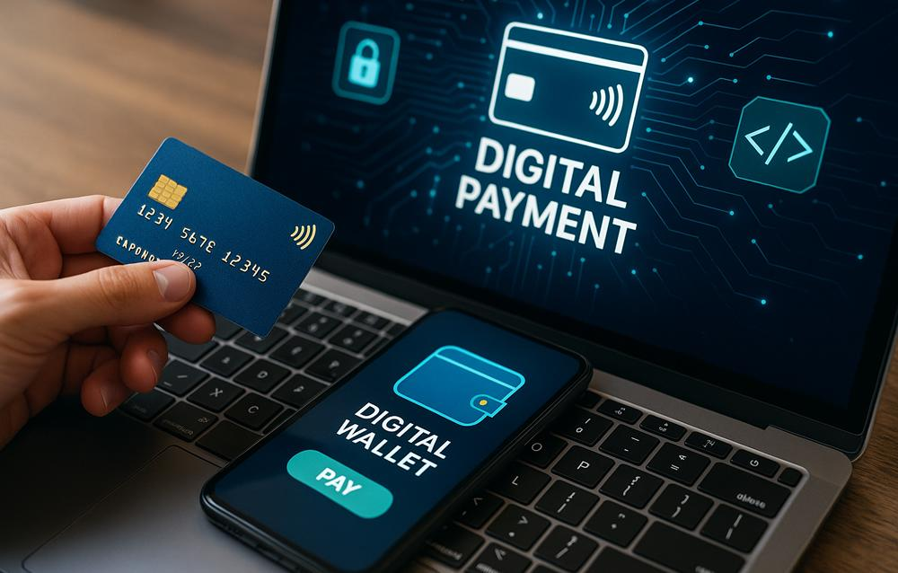

Money is a standard unit used to measure the value of goods, services, assets, and financial transactions. It provides a common basis for determining prices, making payments, recording wealth, and comparing economic value.
Money is measured using currencies, which are issued by governments or monetary authorities and are divided into smaller units.

Definition
# Source: AI Source: Provided by: [Data Path: Persons Table -> ID Column: 1, Name_En Column: Motasem Essam] -> From: [ChatGPT] on [7/17/2026]
Money is a medium of exchange and a standard unit of measurement used to determine, compare, and record economic value.

Purpose of Measuring Money
# Source: AI Source: Provided by: [Data Path: Persons Table -> ID Column: 1, Name_En Column: Motasem Essam] -> From: [ChatGPT] on [7/17/2026]
Money measurement allows people to:
- Buy and sell goods.
- Pay for services.
- Measure wealth.
- Compare prices.
- Save value.
- Record financial transactions.
- Calculate profit and loss.

Currency
# Source: AI Source: Provided by: [Data Path: Persons Table -> ID Column: 1, Name_En Column: Motasem Essam] -> From: [ChatGPT] on [7/17/2026]
Money is measured using a currency.
Examples include:
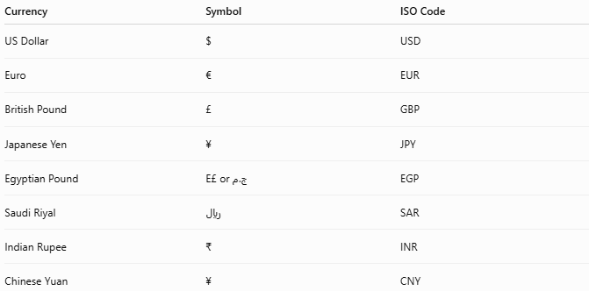
Currency | Symbol | ISO Code
US Dollar | $ | USD
Euro | € | EUR
British Pound | £ | GBP
Japanese Yen | ¥ | JPY
Egyptian Pound | E£ or ج.م | EGP
Saudi Riyal | ﷼ | SAR
Indian Rupee | ₹ | INR
Chinese Yuan | ¥ | CNY

Units of Money
# Source: AI Source: Provided by: [Data Path: Persons Table -> ID Column: 1, Name_En Column: Motasem Essam] -> From: [ChatGPT] on [7/17/2026]
Most currencies are divided into:
- Major unit
- Minor unit
Examples:
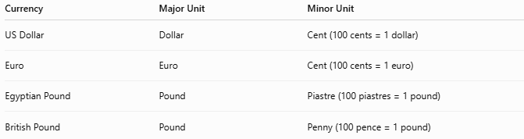
Currency | Major Unit | Minor Unit
US Dollar | Dollar | Cent (100 cents = 1 dollar)
Euro | Euro | Cent (100 cents = 1 euro)
Egyptian Pound | Pound | Piastre (100 piastres = 1 pound)
British Pound | Pound | Penny (100 pence = 1 pound)

Forms of Money
# Source: AI Source: Provided by: [Data Path: Persons Table -> ID Column: 1, Name_En Column: Motasem Essam] -> From: [ChatGPT] on [7/17/2026]
Money exists in several forms:

1. Coins
# Source: AI Source: Provided by: [Data Path: Persons Table -> ID Column: 1, Name_En Column: Motasem Essam] -> From: [ChatGPT] on [7/17/2026]
Metal currency used for smaller amounts.
Examples:
- 1 cent
- 50 piastres
- €1 coin

2. Banknotes (Paper Money)
# Source: AI Source: Provided by: [Data Path: Persons Table -> ID Column: 1, Name_En Column: Motasem Essam] -> From: [ChatGPT] on [7/17/2026]
Printed currency representing larger values.
Examples:
- $20
- €50
- E£100

3. Digital Money
# Source: AI Source: Provided by: [Data Path: Persons Table -> ID Column: 1, Name_En Column: Motasem Essam] -> From: [ChatGPT] on [7/17/2026]
Electronic money stored digitally.
Examples:
- Bank account balances
- Debit cards
- Credit cards
- Mobile wallets
- Online payment services

Characteristics of Good Money
# Source: AI Source: Provided by: [Data Path: Persons Table -> ID Column: 1, Name_En Column: Motasem Essam] -> From: [ChatGPT] on [7/17/2026]
A good monetary system should be:
- Durable
- Portable
- Divisible
- Uniform
- Acceptable
- Stable in value
- Difficult to counterfeit

Functions of Money
# Source: AI Source: Provided by: [Data Path: Persons Table -> ID Column: 1, Name_En Column: Motasem Essam] -> From: [ChatGPT] on [7/17/2026]
Money serves four primary functions:
1. Medium of Exchange
Used to buy and sell goods and services.
2. Unit of Account
Measures and compares prices.
Example:
- A book costs $20.
- A pen costs $2.
3. Store of Value
Allows purchasing power to be saved for future use.
4. Standard of Deferred Payment
Used for loans, credit, and future financial obligations.

Measuring Monetary Value
# Source: AI Source: Provided by: [Data Path: Persons Table -> ID Column: 1, Name_En Column: Motasem Essam] -> From: [ChatGPT] on [7/17/2026]
Examples:
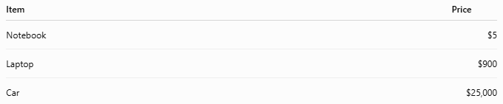
Item | Price
Notebook | $5
Laptop | $900
Car | $25,000
Money provides a common scale for comparing the value of different goods and services.

Currency Exchange
# Source: AI Source: Provided by: [Data Path: Persons Table -> ID Column: 1, Name_En Column: Motasem Essam] -> From: [ChatGPT] on [7/17/2026]
Different countries use different currencies.
Exchange rates determine how one currency converts into another.
Example:
- 1 USD = X EGP
- 1 EUR = Y USD
Exchange rates change over time because of market conditions.

Applications
# Source: AI Source: Provided by: [Data Path: Persons Table -> ID Column: 1, Name_En Column: Motasem Essam] -> From: [ChatGPT] on [7/17/2026]
Money measurement is used in:
- Banking
- Business
- Accounting
- Economics
- Government
- International trade
- Personal finance

Advantages
# Source: AI Source: Provided by: [Data Path: Persons Table -> ID Column: 1, Name_En Column: Motasem Essam] -> From: [ChatGPT] on [7/17/2026]
Money measurement:
- Simplifies trade.
- Enables price comparison.
- Supports saving and investment.
- Facilitates international commerce.
- Provides a common measure of economic value.

Limitations
# Source: AI Source: Provided by: [Data Path: Persons Table -> ID Column: 1, Name_En Column: Motasem Essam] -> From: [ChatGPT] on [7/17/2026]
Money:
- Can lose purchasing power because of inflation.
- Has different values across countries.
- Is affected by exchange-rate changes.
- Does not directly measure non-economic values such as happiness or environmental quality.

Common Mistakes
# Source: AI Source: Provided by: [Data Path: Persons Table -> ID Column: 1, Name_En Column: Motasem Essam] -> From: [ChatGPT] on [7/17/2026]
- Confusing currency with money (currency is one form of money).
- Assuming all currencies have equal value.
- Believing money itself has intrinsic value (modern fiat money derives its value mainly from public trust and government backing).

Interesting Facts
# Source: AI Source: Provided by: [Data Path: Persons Table -> ID Column: 1, Name_En Column: Motasem Essam] -> From: [ChatGPT] on [7/17/2026]
- Most countries issue their own national currency.
- The US Dollar (USD) is one of the world's most widely used reserve currencies.
- Many modern payments occur electronically rather than with physical cash.

Key Points
# Source: AI Source: Provided by: [Data Path: Persons Table -> ID Column: 1, Name_En Column: Motasem Essam] -> From: [ChatGPT] on [7/17/2026]
- Money is the standard measure of economic value.
- Money is measured using currencies.
- Most currencies have:
  - A major unit
  - A minor unit
- Money functions as:
  - A medium of exchange
  - A unit of account
  - A store of value
  - A standard of deferred payment
- Money exists as:
  - Coins
  - Banknotes
  - Digital money
  - Cryptocurrencies

Conclusion
# Source: AI Source: Provided by: [Data Path: Persons Table -> ID Column: 1, Name_En Column: Motasem Essam] -> From: [ChatGPT] on [7/17/2026]
Money is the universal measure of economic value, enabling people to price goods, pay for services, save wealth, and conduct financial transactions. Through standardized currencies, money provides a common system for measuring and comparing value across individuals, businesses, and nations. Whether in physical or digital form, money remains one of the most essential measurement tools in modern economic life.

